[Skip to main content](http://www.rajalakshmicolleges.org/moodle/mod/quiz/review.php" \l "maincontent)

REC-CIS

GE23131-Programming Using C-2024

|  |  |
| --- | --- |
| **Status** | Finished |
| **Started** | Monday, 23 December 2024, 5:33 PM |
| **Completed** | Thursday, 12 December 2024, 11:05 AM |
| **Duration** | 11 days 6 hours |

Top of Form

Question **1**

Correct

Marked out of 3.00

Flag question

Question text

The k-digit number N is an Armstrong number if and only if the k-th power of each digit sums to N.

Given a positive integer N, return true if and only if it is an Armstrong number.

Example 1:

Input:

153

Output:

true

Explanation:

153 is a 3-digit number, and 153 = 1^3 + 5^3 + 3^3.

Example 2:

Input:

123

Output:

false

Explanation:

123 is a 3-digit number, and 123 != 1^3 + 2^3 + 3^3 = 36.

Example 3:

Input:

1634

Output:

true

Note:

1 <= N <= 10^8

Answer:(penalty regime: 0 %)

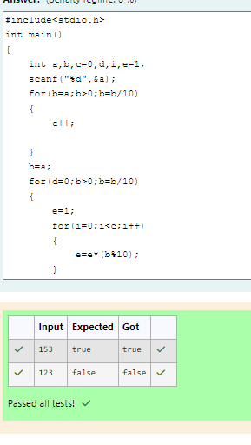

Feedback

|  | **Input** | **Expected** | **Got** |  |
| --- | --- | --- | --- | --- |
|  | 153 | true | true |  |
|  | 123 | false | false |  |

Passed all tests!

Question **2**

Correct

Marked out of 5.00

Flag question

Question text

Take a number, reverse it and add it to the original number until the obtained number is a palindrome. Constraints 1<=num<=99999999 Sample Input 1 32 Sample Output 1 55 Sample Input 2 789 Sample Output 2 66066

Answer:(penalty regime: 0 %)

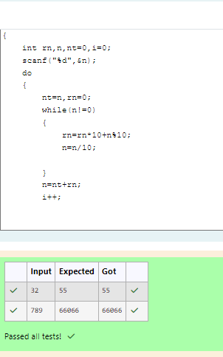

Feedback

|  | **Input** | **Expected** | **Got** |  |
| --- | --- | --- | --- | --- |
|  | 32 | 55 | 55 |  |
|  | 789 | 66066 | 66066 |  |

Passed all tests!

Question **3**

Correct

Marked out of 7.00

Flag question

Question text

A number is considered lucky if it contains either 3 or 4 or 3 and 4 both in it. Write a program to print the nth lucky number. Example, 1st lucky number is 3, and 2nd lucky number is 4 and 3rd lucky number is 33 and 4th lucky number is 34 and so on. Note that 13, 40 etc., are not lucky as they have other numbers in it.

The program should accept a number 'n' as input and display the nth lucky number as output.

Sample Input 1:

3

Sample Output 1:

33

Explanation:

Here the lucky numbers are 3, 4, 33, 34., and the 3rd lucky number is 33.

Sample Input 2:

34

Sample Output 2:

33344

Answer:(penalty regime: 0 %)

Feedback

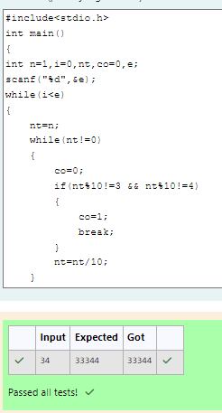

|  | **Input** | **Expected** | **Got** |  |
| --- | --- | --- | --- | --- |
|  | 34 | 33344 | 33344 |  |

Passed all tests!

Bottom of Form

Blocks

[Skip Quiz navigation](http://www.rajalakshmicolleges.org/moodle/mod/quiz/review.php#sb-1)

Quiz navigation

[Question1This page](http://www.rajalakshmicolleges.org/moodle/mod/quiz/review.php#question-118196-1)[Question2This page](http://www.rajalakshmicolleges.org/moodle/mod/quiz/review.php#question-118196-2)[Question3This page](http://www.rajalakshmicolleges.org/moodle/mod/quiz/review.php#question-118196-3)

[Show one page at a time](http://www.rajalakshmicolleges.org/moodle/mod/quiz/review.php?attempt=118068&cmid=123&showall=0)

Blocks